Workflow Stabilization Plan
Section 4 — Apex Insurance Group Integrated Architecture Package

Project | Apex Insurance Group Integrated Architecture and Sign-off Package
Template Section | Section 4 — Workflow Stabilization Assessment
Learner Name | Dennis Lam
Deliverable | AI-Graded File Upload (PDF)

Section summary. Three failure nodes carry the most risk in the Claims workflow. FN-001 is the external public-records API behind the Fraud and Risk Specialist. FN-002 is the Settlement Specialist’s output. FN-003 is the instrumentation of the Fraud-to-Settlement A2A handoff. Each traces to an agent or handoff named in Sections 2 and 3 and has a selected pattern: circuit breaker with fallback, validation failure branch, and observability instrumentation enforced as a release gate. Named spans with specific capture targets back all three. The result: an API outage parks claims instead of producing blank letters, malformed letters never reach an adjuster, and any claim’s agent path can be rebuilt from one correlation_id.

1. Claims Processing Workflow Reference
Workflow Node | Agent / System | Normal Function | Downstream Dependency
Claim document ingestion | Claim Intake / Extraction Agent | Extract extracted_claim from the PDF with Document Intelligence model apex-acord1-property-loss-v3 and kb-claims-intake-guide, with a confidence score per field. | Event Grid trigger and claims-inbox blob; di-apex-claims-prod. Next: ESC-003 gate, then the Policy Cross-Reference Agent.
Policy cross-reference | Policy Cross-Reference Agent | Populate policy_cross_reference from view vw_policy_coverage and kb-claims-policy-wordings. | sqldb-apex-policy. Next: ESC-004 gate, then the Fraud and Risk Specialist.
Fraud and public records check | Fraud and Risk Specialist + external API | Run the five mandatory checks through public_records_lookup, score with score_fraud_signals, return fraud_assessment. | External public-records API via apim-apex-integration-prod (FN-001); redis-apex-claims-prod cache. Next: routing gate.
A2A handoff | Fraud and Risk Specialist → Settlement Specialist (brokered by the Claims Workflow Controller) | Apply routing rules, project the 19-field payload, redact PII, authenticate as uami-claims-workflow-controller, send A2A message/send with contextId = correlation_id. | lang-apex-claims-prod (redaction), Entra ID, appi-apex-claims-prod (span a2a.handoff, FN-003). Next: Settlement Specialist.
Settlement output | Settlement Specialist | Draft letter sections with merge tokens and recommended_settlement_amount_usd (from calculate_settlement), grounded on kb-claims-settlement-templates. | Validation gate V1 to V9 (FN-002), then the Letter Rendering Service, then the adjuster review queue.

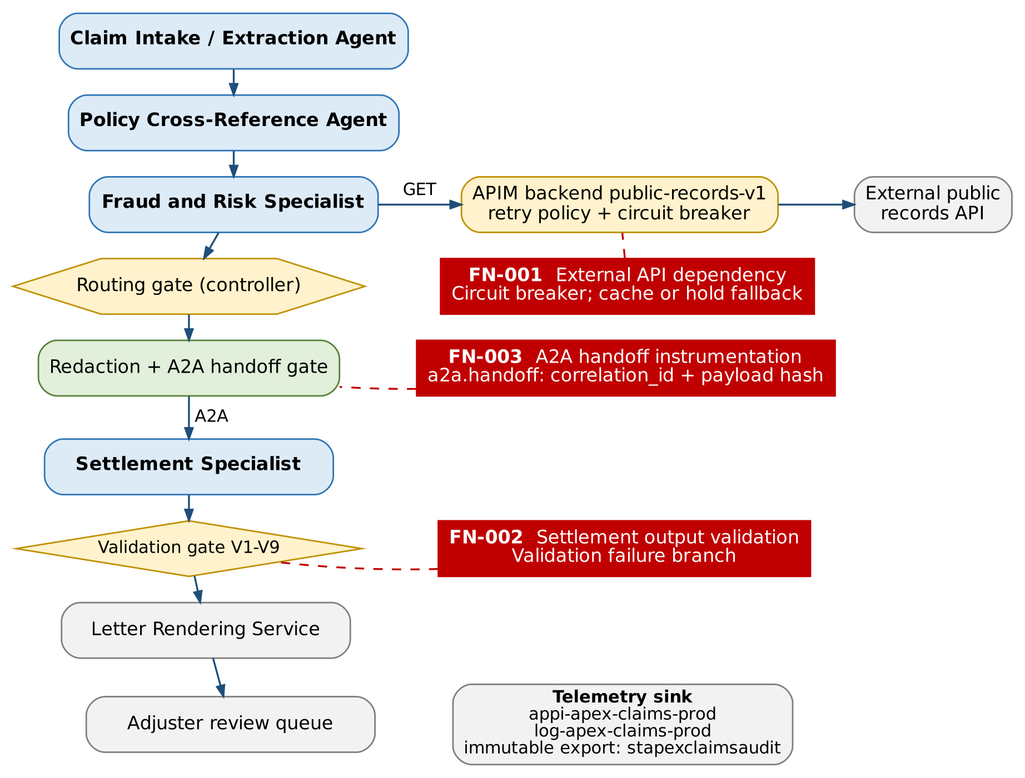
Figure 1. The three failure nodes mapped onto the Claims workflow from Sections 2 and 3

2. Failure Node Assessment
Failure Node ID | Specific Architecture Point | Failure Description | Impact if Unhandled | Selected Error Handling Pattern | Rationale
FN-001 | External API dependency in the fraud and public-records check: Fraud and Risk Specialist tool public_records_lookup → APIM backend public-records-v1 → vendor API (Section 2, Part B pillar 4; Section 3, item 2). | Vendor outage, timeouts above 8 seconds, HTTP 429 throttling or 5xx errors. Outages last minutes to hours, so every claim in flight hits the same failure at once. | The agent either loops on retries (burning tokens and vendor quota) or finishes with missing evidence. A missing check can read as “no adverse records”, giving a false LOW score that hands a possibly fraudulent claim to Settlement. Or the workflow stalls and Settlement receives empty fields, producing the blank or incomplete letter the scenario prohibits. | Circuit breaker (APIM backend circuit-breaker rule) with bounded retry inside it and a two-tier fallback: recent cached result, then checkpointed hold. | Retry alone is insufficient. During a sustained outage, retries multiply load on a failing vendor (retry storm), hold workflow instances open and still end in failure. The breaker fails fast once the threshold is crossed, moves every claim to the fallback without calling the vendor, and probes for recovery. The fallback never guesses a score: a claim either uses a recent real result or waits.
FN-002 | Settlement Specialist output validation: between the Settlement Specialist’s settlement output and the Letter Rendering Service (Section 2, ESC-007; Section 3, Figure 1 validation gate). | LLM output is malformed or incomplete: invalid JSON or schema; a required letter section missing or empty; unknown or unresolved merge tokens; recommended_settlement_amount_usd inconsistent with limit and deductible; wrong state disclosure clause; or a raw PII pattern in generated text. | A blank, incomplete or wrong settlement letter reaches an adjuster or the insured. That means regulatory exposure under state unfair claims settlement practices rules, over- or under-payment, and PII disclosure if the model leaks a name or account number. | Validation failure branch: deterministic validator (JSON Schema plus rules V1 to V9, Table 3a) as a hard gate; one regeneration with field-level errors; then manual drafting (ESC-007). | Downstream protection: the renderer accepts only output with letter_validation_status = PASSED, so an unvalidated letter can never be rendered. A blind retry of a generative step can fail in a new way, so retries are capped at one, with the error list as context; after that a person drafts the letter.
FN-003 | Agent interaction observability at the A2A handoff Fraud and Risk Specialist → Settlement Specialist, brokered by the Claims Workflow Controller (Section 3, items 3.2 and 3.4), plus the invoke_agent spans of all four agents. | Spans missing or unlinked: correlation_id dropped between hops, exporter misconfigured after a deployment, sampling discards handoff spans, or a developer logs the full payload, including PII, while debugging. | Compliance cannot reconstruct which agent produced which decision for a regulatory exam or a disputed claim, and cannot prove the SIU branch fired, so the “all interactions auditable” requirement fails silently. Logging full payloads would copy policyholder PII into telemetry, breaching state insurance data-security rules. | Observability instrumentation as an enforced control: OpenTelemetry tracing with GenAI semantic conventions through the Azure Monitor OpenTelemetry Distro, no sampling on Claims spans, a release gate and a fail-closed handoff check. | Audit requirement: each interaction must be attributable and tamper-evident. The correlation ID on every span and a payload hash (not the payload) prove what was sent without storing PII. Missing telemetry is invisible at run time, so it is checked at release (synthetic claim run) and at every handoff (no correlation ID, no handoff).
Why these three nodes: they rank highest on likelihood × impact across the nodes in item 1. The external API is the only dependency outside Apex’s control and the direct cause of the blank-letter risk. The Settlement output is the only LLM output that becomes customer-facing. The handoff is where audit evidence is most easily lost. Lower-ranked nodes are already covered: intake extraction errors by ESC-003 (confidence < 0.80), policy database outages by retry against an internal SLA, and model throttling (HTTP 429) by per-Project TPM quotas and SDK retry.
Table 3a. Settlement output validation rules used by the FN-002 validation failure branch
Rule | Validation check on Settlement Specialist output (FN-002)
V1 | Output validates against the settlement block of ClaimCaseOutput v1.0 and the letter-section schema SettlementLetterDraft v1.0.
V2 | All required letter sections are present and non-empty: claim reference, loss description, coverage summary, settlement calculation, deductible statement, exclusions cited (when coverage_status = PARTIAL), state disclosure and dispute rights.
V3 | Only approved merge tokens appear ({{INSURED_NAME}}, {{PROPERTY_ADDRESS}}, {{POLICY_NUMBER}}); no other {{…}} token and no empty placeholder.
V4 | recommended_settlement_amount_usd equals the calculate_settlement result (lower of covered loss and coverage_limit_usd, minus deductible_usd, floored at 0) to within $0.01.
V5 | recommended_settlement_amount_usd ≤ coverage_limit_usd.
V6 | The disclosure clause ID matches the property_location_state template in kb-claims-settlement-templates.
V7 | claim_id and correlation_id match the case record and the A2A contextId.
V8 | PII scan (Language PII detection plus regex) of the generated text finds no names, addresses, policy or account numbers outside merge tokens.
V9 | If settlement_hold_required = true, the letter status is DRAFT_HOLD and release is disabled.

3. Retry and Circuit Breaker Configuration
Failure Node | Retry Count | Backoff Strategy | Circuit Open Condition | Fallback / Alternate Route | Recovery Condition
FN-001 | 2 retries (3 attempts in total) per lookup, only on HTTP 429, 502, 503, 504 or timeout. Never on 400, 401, 403 or 404. | Exponential with full jitter: base 1 s, factor 2, cap 8 s (about 1 s, then 2 s, then 4 s). Honors Retry-After. Per-attempt timeout 8 s; total budget 20 s per lookup. | APIM backend circuit-breaker rule trips when 5 failures (HTTP 429, 500 to 599, or timeout) occur within 60 seconds; trip duration 120 seconds; Retry-After honored. While open, no call reaches the vendor. | Tier 1: APIM on-error returns the cached vendor response from redis-apex-claims-prod if it is 30 days old or less for the same entity and address; public_records_check_status = CACHED. Not allowed when claimed_amount_usd > $250,000.  Tier 2: no valid cache gives INDETERMINATE. The controller checkpoints the claim, parks it in sbq-external-verification-hold (retried every 15 minutes) and after 4 hours routes it to the adjuster (ESC-005). Settlement never runs. | Half-open after 120 s with one probe call; the circuit closes after 3 consecutive successful probes under 3 s. Parked claims replay oldest first, at most 10 at a time (no thundering herd). CACHED results on claims not yet settled are re-verified live.
FN-002 | 1 regeneration (2 attempts in total). | None (immediate). The regeneration prompt includes the failed rule IDs and field paths. | N/A per claim. Operational guard: if more than 5% of letters fail validation within 1 hour, Claims Platform on-call is alerted (a sign of prompt or model regression). | Validation failure branch: the draft JSON stays in the case record with letter_validation_status = FAILED and nothing is rendered; the claim goes to sbq-adjuster-review for manual drafting (ESC-007) with the error list attached. | All rules V1 to V9 pass. Only then does the Letter Rendering Service accept the output.
FN-003 | N/A for the business flow (the exporter’s local buffer retries telemetry export). | N/A | N/A | Block release or route to instrumentation remediation:  - Release gate: a synthetic claim run in pre-production must show every required span in item 4 linked by one correlation_id, or the deployment is blocked.  - Runtime: a handoff without correlation_id, or without a started a2a.handoff span, is rejected (fail closed) and on-call is alerted.  - Drift: if ingested claims.workflow.run spans fall more than 2% below the workflow count for 15 minutes, an alert opens an instrumentation remediation ticket. | Required spans visible in telemetry with correlation_id for 100% of synthetic runs, and a daily reconciliation of claim count against claims.workflow.run spans shows zero gaps.

4. Observability Specification
Span Name | Architecture Point | Capture Targets | PII Handling | Owner / Consumer
fraud_api.call | Fraud and public records API call (public_records_lookup → APIM public-records-v1) | API response status, latency (ms), retry count, circuit state (closed, open or half-open), fallback tier (none, CACHED, INDETERMINATE), cache age, APIM request ID, operation name | No full payload; claim reference (correlation_id) only; no entity names or addresses | Claims Platform Engineering (SRE); on-call alerting
settlement_output.validation | Settlement Specialist output validation gate | Validation pass or fail, schema version, failed rule IDs (V1 to V9), field-level error detail (field path and rule), attempt number (1 or 2) | No raw PII in validation logs: errors list field paths and rule IDs, never values | Claims Operations QA lead; Claims Platform Engineering
a2a.handoff | Inter-agent handoff events (Fraud and Risk Specialist → Settlement Specialist via the controller) | Sending agent ID, receiving agent ID, correlation ID, handoff_id, timestamp, payload SHA-256 hash, schema_version, caller principal (UAMI object ID), redaction_applied, route | Payload hash only; no full handoff payload | Claims Compliance and Internal Audit (consumer); Claims Platform Engineering (owner)
claims.workflow.run (root span) | Claims Workflow Controller, one per claim run | correlation_id, claim_id, workflow version, final workflow_status, route, escalation_ids, total duration, total tokens | Identifiers only | Claims Operations manager (SLA); Internal Audit
invoke_agent {agent_name} with child execute_tool {tool_name} | Each of the four specialist agents and their tool calls | gen_ai.agent.name, gen_ai.agent.id, gen_ai.request.model, gen_ai.usage.input_tokens, gen_ai.usage.output_tokens, tool-call count, duration, outcome | Prompt and completion content capture disabled in production | Claims Platform Engineering; FinOps (token showback)
fraud.routing_decision | Routing gate in the controller | fraud_risk_score, risk_classification, rule ID fired, routing-rules version, route, settlement_hold_required | No PII | Claims Compliance and Internal Audit; SIU Manager
pii.redaction | Redaction step of the handoff gate | Count of entities redacted per category, Language API status, regex backstop hits, duration | Counts only, never values | Operations Privacy Officer; Claims Platform Engineering
escalation.enqueue | Controller → Service Bus escalation queues | Condition ID (ESC-001 to ESC-007), queue name, Service Bus message ID, CorrelationId, checkpoint ID | Identifiers only | Queue owners (SIU, Large Loss Unit, adjusters); Internal Audit
Capture target for every span: Application Insights appi-apex-claims-prod (workspace-based, Log Analytics log-apex-claims-prod), with sampling disabled for Claims spans and attribute apex.correlation_id on every span. A daily export goes to stapexclaimsaudit under a time-based immutability policy (7 years, pending Records Management confirmation). Engineers use the Foundry tracing view in proj-apex-claims-processing. Claims Compliance and Internal Audit have read-only access to the audit workspace. Legal receives curated audit reports, never direct access, which preserves the Section 1 isolation.

5. Stabilization Decision Summary
Question | Learner Response
Can the workflow survive external API outage without blank settlement letters? | Yes. The APIM circuit breaker (FN-001) fails fast after 5 failures in 60 seconds. Claims then either use a real cached result of 30 days or less (CACHED, claims of $250,000 or less only) or are parked as AWAITING_EXTERNAL_VERIFICATION with a checkpoint. The Settlement Specialist only receives a handoff with a non-null fraud_risk_score and status COMPLETED or CACHED, and the validation gate (FN-002) is a second barrier. No blank or partial letter can be produced: claims are delayed, not degraded. After 4 hours an adjuster takes over (ESC-005).
Can malformed settlement output be stopped before downstream use? | Yes. The validation failure branch (FN-002) checks every Settlement output against the schema and rules V1 to V9 before rendering. There is one regeneration with the error list, then manual drafting (ESC-007). The Letter Rendering Service only accepts letter_validation_status = PASSED, and an adjuster releases every letter, so a malformed draft never reaches a policyholder.
Can compliance reconstruct agent interactions for audit? | Yes. Every agent invocation, tool call, routing decision, redaction, handoff, validation and escalation emits a span carrying apex.correlation_id (FN-003). Handoffs record sender, receiver, caller identity and a payload hash. Spans are exported daily to immutable storage. A release gate and a fail-closed handoff check stop the workflow from running without instrumentation. Compliance rebuilds a claim’s full path with one query on correlation_id.
Open risks or assumptions | - R1: Vendor outages longer than 4 hours shift work to adjusters; staffing for that surge is not yet planned (owner: Claims Operations).  - R2: The 30-day cache limit and the $250,000 cut-off for cached results are initial values for SIU to confirm.  - R3: Circuit-breaker thresholds (5 failures in 60 seconds, 120-second trip) need tuning against a vendor latency baseline during the pilot.  - R4: Fraud score calibration (fraud-weights v2026.10) needs back-testing on closed SIU cases before go-live. If thresholds 0.60 and 0.85 move, Sections 2 and 3 must be updated together.  - R5: Seven-year telemetry retention and immutability are pending Records Management (Section 1, assumption A5).  - R6: Legal cannot access claims telemetry by design; regulatory exam requests are served through Internal Audit reports.

Submission Checklist
☑ Three failure nodes are specific to the Claims Processing architecture.
☑ External fraud/public records API uses a circuit breaker, not retry-only handling.
☑ Settlement Specialist malformed output uses a validation failure branch.
☑ Observability spans name specific capture targets.
☑ A2A handoff instrumentation includes correlation ID and payload hash, not full PII payload.
☑ Failure nodes trace back to agents or handoffs defined in Sections 2 and 3.

